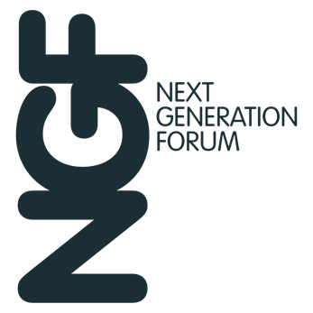

Name:
Company:

SPONSOR FEEDBACK 2024
Your feedback is extremely important to us, so we would very much appreciate you taking the time to complete and return this form. Where requested, please score each item with a maximum score of 10 for outstanding down to 0 for awful.

DELEGATES Score
How happy were you with the list of delegates? /10
Comments:

Were there any delegates, whom you would have preferred not to have been invited? This will be treated in strict confidence.
Comments:

CONCEPT
The Next Generation Forum aims to showcase eight interesting investment ideas from mainstream groups, be those managers, strategies or funds, which the audience will not have seen before. Do you feel its objectives remain clear and does it continue to fulfil its brief successfully?
Comments:

CONFERENCE FORMAT
Is there a good balance between business sessions and informal networking?
Comments:

Are there any changes you would like to see to the format?
Comments:

MARKETING
Did you like the design concept for the event? Yes/No
Comments:

Did you feel that the website, online brochure and branding at the event gave you sufficient exposure? www.ngfevents.com Yes/No
Comments:

VENUE Score
Overall, how appropriate was the venue for this event? /10
Please score each individual item:
Location /10 Meeting room facilities /10
Service /10 Food and Beverage /10
Comments:

ORGANISATION Score
Please rate the conference organisation /10
Please comment on any areas for improvement
Comments:

OVERALL CONFERENCE RATING Score
Please comment on how the event can be improved /10
Comments:

Would you be interested in supporting the Next Generation Forum in 2025?
Comments:

TESTIMONIAL
If you would be happy to recommend the Next Generation Forum and/or Infusion Events, we would be grateful for your comments. Please indicate if you are happy for these to be used in our marketing promotional materials and whether we can use your name or your company name or (preferably) both: Yes/No

Thank you for taking the time to complete this form. Please return to: sally.doyle@infusionevents.com by Friday 26th January

